**Chore Change**

Company: Big Ike Inc.

Submitted By: Isaac Medlin

Submitted To: Gary Clark

Email: [Isaac.medlin@oit.edu](mailto:Isaac.medlin@oit.edu)

Date: Tuesday, October 14, 2020

Version: 1.0

# Signatory Page

This document was accepted by:

X_____________________________ _____________________

Signature (Gary Clark) Date

This document was submitted by:

X_____________________________ _____________________

Signature (Isaac Medlin) Date

# Revision History

|  |  |  |  |  |  |
| --- | --- | --- | --- | --- | --- |
| Author | Company | Version | Date | Filename | comments |
| Isaac Medlin | Big Ike Inc. | 1.0 | 10/14/2020 | Use Case Model | Initial Draft |
| Isaac Medlin | Big Ike Inc. | 1.1 | 11/2/2020 | Use Case Model | Crud matrix updated |
| Isaac Medlin | Big Ike Inc. | 1.2 | 12/3/20 20 | Use Case Model | Added Sequence Diagrams |

Table of Contents

Signatory Page ii

Revision History iii

Context Diagram 1

Use Case Catalog Table 1

Actor Catalog Table 2

Feature Verification Matrix 2

Use Case Specifications 3

Registering 3

Logging in 7

Add Chore 11

Adding Child Account 15

Paying out Child Account 19

Child completing a chore 23

Approving a Chore 27

Switch Account 31

Account Page 35

CRUD Matrix 39

Low Fidelity UI 39

Parent GUI 39

Child GUI 42

Sequence Diagrams 43

Registering 44

Logging In 45

Add Chore 46

Adding Child Account 46

Paying out child 47

Child Completing a Chore 48

Approving a chore 48

Switch Account 49

Account Page 50

Glossary 51

Appendix A 51

Business Rules 51

# Context Diagram

# Use Case Catalog Table

|  |  |  |
| --- | --- | --- |
| Use Case ID | Use Case Name | Description |
| 100 | Registering | Registers an account with the app. |
| 200 | Logging in | Logs a user into the app. |
| 300 | Add Chore | Adds a chore to the database. |
| 400 | Adding child account | Adds a child account under a parent account. |
| 500 | Paying out a Child | Takes their bank account amount, notifies parent, and then sets the amount to 0. |
| 600 | Child Completing a chore | Sets chore status to pending, waiting for parents’ approval. |
| 700 | Approving a chore | Sets chore status to completed, the chore dollar amount gets added to the child’s bank. |
| 800 | Switch account | Switches between the accounts on the phone |
| 900 | Account Page | Gives the option to change name, password, and if it’s a parent account, manage children linked to it |

# Actor Catalog Table

|  |  |  |
| --- | --- | --- |
| Name | Type | Description |
| Parent User | Person | App owner with a valid sign in |
| Child User | Person | App owner with a valid sign in |

# Feature Verification Matrix

|  |  |  |
| --- | --- | --- |
| Feature #’s | Use Case ID | Use Case Name |
| 2 | 100 | Registering |
| 3, 9, 8 | 300 | Add Chore |
| 4 | 500 | Paying out Child |
| 5 | 900 | Account Page |
| 6, 10 | 800 | Switch Account |
| 7 | 600 | Child Completing a chore |
| 7.3-7.4 | 700 | Approving a chore |
| 5.3 | 400 | Adding Child Account |

# Use Case Specifications

## Registering

|  |  |
| --- | --- |
| **General Information** | |
| Use Case Name\Number: 100  Subject Area: Account  Description: Creates an account | Responsible Analyst: Medlin |

|  |  |
| --- | --- |
| **Requirements/Feature Trace** | |
| **REQ#** | **Requirements Name and / or Short Description** |
| 2 | User must be able to register an account |

|  |  |  |
| --- | --- | --- |
| **Revision History** | | |
| **Author** | **Date** | **Comments** |
| Medlin | 10/14/20 | First Draft |

|  |  |  |
| --- | --- | --- |
| **Insertion Points in other Use Cases (Adds Only)** | | |
| **Use Case Name** | **Use Case Number** | **Step Inserted After** |
| **N/A** |  |  |

|  |  |  |
| --- | --- | --- |
| **Actors** | | |
| **Actor Name** | **Person/System** | **Brief Description** |
| Parent | Person | Parent with a Samsung |
| Child | Person | Child with a Samsung, or they have a parent with a Samsung |

|  |  |
| --- | --- |
| **Pre-Conditions** | |
| **#** | **Description** |
| 1 | Welcome Screen |

|  |
| --- |
| **Start Stimulus** |
| User clicks on App icon |

|  |  |  |  |
| --- | --- | --- | --- |
| **Use Case Main Course Steps** | | | |
| **Number** | **Description** | **Adds/Alt Name/Number** | **Bus Rule#** |
| 1 | Open app on phone |  |  |
| 2 | Clicks on register account |  |  |
| 3 | App prompts for username, password, security question and account type |  |  |
| 4 | User enters information |  |  |
| 5 | User hits enter |  |  |

|  |  |  |
| --- | --- | --- |
| **Exception Conditions** | | |
| **Exception Situations** | **Action(s) on Exception** | **Adds\Alt UC #** |
| User enters invalid or taken information | App prompts that it is not valid or taken |  |

|  |  |
| --- | --- |
| **Post-Conditions** | |
| **#** | **Description** |
| 1 | Welcome screen |
| 2 | User is logged in |

|  |  |  |
| --- | --- | --- |
| **Candidate Objects** | | |
| **Class/Object Name** | **Descriptions** | **Possible**  **attributes** |
| App user | Can use the chore functions of the app | Name, Date |
| Child | Can view the posted chore | Name |

|  |  |  |  |  |  |
| --- | --- | --- | --- | --- | --- |
| **Assumptions** | | | | | |
| **#** | **Assumption** | **Date**  **Raised** | **Raised**  **By** | **Date**  **Verified** | **Verified By** |
| 1 | N/A |  |  |  |  |

|  |  |  |  |  |  |
| --- | --- | --- | --- | --- | --- |
| **Issues** | | | | | |
| **#** | **Issue** | **Date**  **Raised** | **Raised**  **By** | **Date**  **Verified** | **Verified By** |
| 1 | Can’t be tested yet | 10/1/2020 | Isaac |  |  |

|  |  |  |
| --- | --- | --- |
| **Other Comments** | | |
| **Author** | **Comment** | **Date** |
| N/A |  |  |

|  |
| --- |
| **Frequency of Execution** |
| **Frequency:**  Minimum: 0 Maximum: 100 Average: 3 (OR)Fixed:  **Per:** Hour:Day:  Week:  Month:  Other: |

|  |  |  |  |  |  |  |  |
| --- | --- | --- | --- | --- | --- | --- | --- |
| **Timing Information** | | | | | | | |
| **#** | **At/**  **Between** | **Step(s)** | **Timing**  **Unit** | **Minimum** | **Average** | **Maximum** | **Comments** |
| 1 | At | 1 | Seconds | N/A | N/A | 2 | Don’t want them to get impatient while the app opens |
| 2 | At | 2 | Seconds | N/A | N/A | 2 | Don’t want them to spam the register button |
| 3 | At | 5 | Seconds | N/A | N/A | 4 | Don’t want them spamming the complete button |

|  |  |  |  |  |  |  |
| --- | --- | --- | --- | --- | --- | --- |
| **Volume Information** | | | | | | |
| **#** | **Step #** | **Unit of**  **Measure** | **Minimum** | **Average** | **Maximum** | **Comments** |
| 1 | 5 | Bytes | 1 | 5 | 10 | Adds information to DB |

## Logging in

|  |  |
| --- | --- |
| **General Information** | |
| Use Case Name\Number: 200  Subject Area: Account  Description: Logs into an account | Responsible Analyst: Medlin |

|  |  |
| --- | --- |
| **Requirements/Feature Trace** | |
| **REQ#** | **Requirements Name and / or Short Description** |
| 6, 10 | User must be able to log into an account |

|  |  |  |
| --- | --- | --- |
| **Revision History** | | |
| **Author** | **Date** | **Comments** |
| Medlin | 10/14/20 | First Draft |

|  |  |  |
| --- | --- | --- |
| **Insertion Points in other Use Cases (Adds Only)** | | |
| **Use Case Name** | **Use Case Number** | **Step Inserted After** |
| **N/A** |  |  |

|  |  |  |
| --- | --- | --- |
| **Actors** | | |
| **Actor Name** | **Person/System** | **Brief Description** |
| Parent | Person | Parent with a Samsung |
| Child | Person | Child with a Samsung, or they have a parent with a Samsung |

|  |  |
| --- | --- |
| **Pre-Conditions** | |
| **#** | **Description** |
| 1 | Welcome Screen |

|  |
| --- |
| **Start Stimulus** |
| User clicks on App icon |

|  |  |  |  |
| --- | --- | --- | --- |
| **Use Case Main Course Steps** | | | |
| **Number** | **Description** | **Adds/Alt Name/Number** | **Bus Rule#** |
| 1 | Open app on phone |  |  |
| 2 | App prompts for username and password. |  |  |
| 3 | User enters information |  |  |
| 4 | User hits enter |  |  |

|  |  |  |
| --- | --- | --- |
| **Exception Conditions** | | |
| **Exception Situations** | **Action(s) on Exception** | **Adds\Alt UC #** |
| User enters invalid information | App prompts that the login information is not valid. |  |

|  |  |
| --- | --- |
| **Post-Conditions** | |
| **#** | **Description** |
| 1 | Welcome screen |
| 2 | User is logged in |

|  |  |  |
| --- | --- | --- |
| **Candidate Objects** | | |
| **Class/Object Name** | **Descriptions** | **Possible**  **attributes** |
| App user | Can use the chore functions of the app | Name, Date |
| Child | Can view the posted chore | Name |

|  |  |  |  |  |  |
| --- | --- | --- | --- | --- | --- |
| **Assumptions** | | | | | |
| **#** | **Assumption** | **Date**  **Raised** | **Raised**  **By** | **Date**  **Verified** | **Verified By** |
| 1 | N/A |  |  |  |  |

|  |  |  |  |  |  |
| --- | --- | --- | --- | --- | --- |
| **Issues** | | | | | |
| **#** | **Issue** | **Date**  **Raised** | **Raised**  **By** | **Date**  **Verified** | **Verified By** |
| 1 | Can’t be tested yet | 10/1/2020 | Isaac |  |  |

|  |  |  |
| --- | --- | --- |
| **Other Comments** | | |
| **Author** | **Comment** | **Date** |
| N/A |  |  |

|  |
| --- |
| **Frequency of Execution** |
| **Frequency:**  Minimum: 0 Maximum: 100 Average: 3 (OR)Fixed:  **Per:** Hour:Day:  Week:  Month:  Other: |

|  |  |  |  |  |  |  |  |
| --- | --- | --- | --- | --- | --- | --- | --- |
| **Timing Information** | | | | | | | |
| **#** | **At/**  **Between** | **Step(s)** | **Timing**  **Unit** | **Minimum** | **Average** | **Maximum** | **Comments** |
| 1 | At | 5 | Seconds | N/A | N/A | 4 | Don’t want them spamming the login button |

|  |  |  |  |  |  |  |
| --- | --- | --- | --- | --- | --- | --- |
| **Volume Information** | | | | | | |
| **#** | **Step #** | **Unit of**  **Measure** | **Minimum** | **Average** | **Maximum** | **Comments** |
| 1 | 5 | Bytes | 1 | 5 | 10 | Information added to the fields, checks DB if the information is correct. |

## Add Chore

|  |  |
| --- | --- |
| **General Information** | |
| Use Case Name\Number: 300  Subject Area: Chore Task  Description: Add Chore | Responsible Analyst: Medlin |

|  |  |
| --- | --- |
| **Requirements/Feature Trace** | |
| **REQ#** | **Requirements Name and / or Short Description** |
| 3,8,9 | Adding chores into the DB |

|  |  |  |
| --- | --- | --- |
| **Revision History** | | |
| **Author** | **Date** | **Comments** |
| Medlin | 10/14/20 | First Draft |

|  |  |  |
| --- | --- | --- |
| **Insertion Points in other Use Cases (Adds Only)** | | |
| **Use Case Name** | **Use Case Number** | **Step Inserted After** |
| **N/A** |  |  |

|  |  |  |
| --- | --- | --- |
| **Actors** | | |
| **Actor Name** | **Person/System** | **Brief Description** |
| Parent | Person | Parent with a Samsung |
| Child | Person | Child with a Samsung, or they have a parent with a Samsung |

|  |  |
| --- | --- |
| **Pre-Conditions** | |
| **#** | **Description** |
| 1 | Welcome Screen |
| 2 | Logged into the app as a parent account |

|  |
| --- |
| **Start Stimulus** |
| User clicks on App icon |

|  |  |  |  |
| --- | --- | --- | --- |
| **Use Case Main Course Steps** | | | |
| **Number** | **Description** | **Adds/Alt Name/Number** | **Bus Rule#** |
| 1 | Click add chore button |  |  |
| 2 | App prompts for chore information |  |  |
| 3 | User enters information |  |  |
| 4 | User hits enter |  |  |

|  |  |  |
| --- | --- | --- |
| **Exception Conditions** | | |
| **Exception Situations** | **Action(s) on Exception** | **Adds\Alt UC #** |
| User enters invalid information | App prompts that the required chore information is not valid. |  |

|  |  |
| --- | --- |
| **Post-Conditions** | |
| **#** | **Description** |
| 1 | Gets brought back to main screen |
| 2 | Chore is posted |

|  |  |  |
| --- | --- | --- |
| **Candidate Objects** | | |
| **Class/Object Name** | **Descriptions** | **Possible**  **attributes** |
| App user | Can use the chore functions of the app | Name, Date |
| Child | Can view the posted chore | Name |

|  |  |  |  |  |  |
| --- | --- | --- | --- | --- | --- |
| **Assumptions** | | | | | |
| **#** | **Assumption** | **Date**  **Raised** | **Raised**  **By** | **Date**  **Verified** | **Verified By** |
| 1 | N/A |  |  |  |  |

|  |  |  |  |  |  |
| --- | --- | --- | --- | --- | --- |
| **Issues** | | | | | |
| **#** | **Issue** | **Date**  **Raised** | **Raised**  **By** | **Date**  **Verified** | **Verified By** |
| 1 | Can’t be tested yet | 10/1/2020 | Isaac |  |  |

|  |  |  |
| --- | --- | --- |
| **Other Comments** | | |
| **Author** | **Comment** | **Date** |
| N/A |  |  |

|  |
| --- |
| **Frequency of Execution** |
| **Frequency:**  Minimum: 0 Maximum: 100 Average: 3 (OR)Fixed:  **Per:** Hour:Day:  Week:  Month:  Other: |

|  |  |  |  |  |  |  |  |
| --- | --- | --- | --- | --- | --- | --- | --- |
| **Timing Information** | | | | | | | |
| **#** | **At/**  **Between** | **Step(s)** | **Timing**  **Unit** | **Minimum** | **Average** | **Maximum** | **Comments** |
| 1 | At | 5 | Seconds | N/A | N/A | 4 | Don’t want them spamming the enter button |

|  |  |  |  |  |  |  |
| --- | --- | --- | --- | --- | --- | --- |
| **Volume Information** | | | | | | |
| **#** | **Step #** | **Unit of**  **Measure** | **Minimum** | **Average** | **Maximum** | **Comments** |
| 1 | 5 | Bytes | 1 | 5 | 10 | Information added to the fields, adds chore to db. |

## Adding Child Account

|  |  |
| --- | --- |
| **General Information** | |
| Use Case Name\Number: 400  Subject Area: Account Tasks  Description: Add Child to parent account | Responsible Analyst: Medlin |

|  |  |
| --- | --- |
| **Requirements/Feature Trace** | |
| **REQ#** | **Requirements Name and / or Short Description** |
| 3,5 | Adding Child under a parent account |

|  |  |  |
| --- | --- | --- |
| **Revision History** | | |
| **Author** | **Date** | **Comments** |
| Medlin | 10/14/20 | First Draft |

|  |  |  |
| --- | --- | --- |
| **Insertion Points in other Use Cases (Adds Only)** | | |
| **Use Case Name** | **Use Case Number** | **Step Inserted After** |
| **N/A** |  |  |

|  |  |  |
| --- | --- | --- |
| **Actors** | | |
| **Actor Name** | **Person/System** | **Brief Description** |
| Parent | Person | Parent with a Samsung |
| Child | Person | Child with a Samsung, or they have a parent with a Samsung |

|  |  |
| --- | --- |
| **Pre-Conditions** | |
| **#** | **Description** |
| 1 | Welcome Screen |
| 2 | Logged into the app as a parent account |

|  |
| --- |
| **Start Stimulus** |
| User clicks on App icon |

|  |  |  |  |
| --- | --- | --- | --- |
| **Use Case Main Course Steps** | | | |
| **Number** | **Description** | **Adds/Alt Name/Number** | **Bus Rule#** |
| 1 | Click account |  |  |
| 2 | Click add child button |  |  |
| 3 | App prompts for child unique id |  |  |
| 4 | User hits Add button. |  |  |

|  |  |  |
| --- | --- | --- |
| **Exception Conditions** | | |
| **Exception Situations** | **Action(s) on Exception** | **Adds\Alt UC #** |
| User enters invalid information | App prompts that the required id is not valid. |  |

|  |  |
| --- | --- |
| **Post-Conditions** | |
| **#** | **Description** |
| 1 | Gets brought back to main screen |
| 2 | Childs added underneath parent |

|  |  |  |
| --- | --- | --- |
| **Candidate Objects** | | |
| **Class/Object Name** | **Descriptions** | **Possible**  **attributes** |
| App user | Can use the chore functions of the app | Name, Date |
| Child | Can view the posted chore | Name |

|  |  |  |  |  |  |
| --- | --- | --- | --- | --- | --- |
| **Assumptions** | | | | | |
| **#** | **Assumption** | **Date**  **Raised** | **Raised**  **By** | **Date**  **Verified** | **Verified By** |
| 1 | N/A |  |  |  |  |

|  |  |  |  |  |  |
| --- | --- | --- | --- | --- | --- |
| **Issues** | | | | | |
| **#** | **Issue** | **Date**  **Raised** | **Raised**  **By** | **Date**  **Verified** | **Verified By** |
| 1 | Can’t be tested yet | 10/1/2020 | Isaac |  |  |

|  |  |  |
| --- | --- | --- |
| **Other Comments** | | |
| **Author** | **Comment** | **Date** |
| N/A |  |  |

|  |
| --- |
| **Frequency of Execution** |
| **Frequency:**  Minimum: 0 Maximum: 100 Average: 3 (OR)Fixed:  **Per:** Hour:Day:  Week:  Month:  Other: |

|  |  |  |  |  |  |  |  |
| --- | --- | --- | --- | --- | --- | --- | --- |
| **Timing Information** | | | | | | | |
| **#** | **At/**  **Between** | **Step(s)** | **Timing**  **Unit** | **Minimum** | **Average** | **Maximum** | **Comments** |
| 1 | At | 5 | Seconds | N/A | N/A | 4 | Don’t want them spamming the add button |

|  |  |  |  |  |  |  |
| --- | --- | --- | --- | --- | --- | --- |
| **Volume Information** | | | | | | |
| **#** | **Step #** | **Unit of**  **Measure** | **Minimum** | **Average** | **Maximum** | **Comments** |
| 1 | 5 | Bytes | 1 | 5 | 10 | Information added to the fields, adds chore to db. |

## Paying out Child Account

|  |  |
| --- | --- |
| **General Information** | |
| Use Case Name\Number: 500  Subject Area: Account Tasks  Description: Paying out child’s bank | Responsible Analyst: Medlin |

|  |  |
| --- | --- |
| **Requirements/Feature Trace** | |
| **REQ#** | **Requirements Name and / or Short Description** |
| 4 | Paying out the child accounts bank |

|  |  |  |
| --- | --- | --- |
| **Revision History** | | |
| **Author** | **Date** | **Comments** |
| Medlin | 10/14/20 | First Draft |

|  |  |  |
| --- | --- | --- |
| **Insertion Points in other Use Cases (Adds Only)** | | |
| **Use Case Name** | **Use Case Number** | **Step Inserted After** |
| **N/A** |  |  |

|  |  |  |
| --- | --- | --- |
| **Actors** | | |
| **Actor Name** | **Person/System** | **Brief Description** |
| Parent | Person | Parent with a Samsung |
| Child | Person | Child with a Samsung, or they have a parent with a Samsung |

|  |  |
| --- | --- |
| **Pre-Conditions** | |
| **#** | **Description** |
| 1 | Welcome Screen |
| 2 | Logged into the app as a child account |

|  |
| --- |
| **Start Stimulus** |
| User clicks on App icon |

|  |  |  |  |
| --- | --- | --- | --- |
| **Use Case Main Course Steps** | | | |
| **Number** | **Description** | **Adds/Alt Name/Number** | **Bus Rule#** |
| 1 | Click bank tab |  |  |
| 2 | Click cash out button |  |  |
| 3 | App notifies the parent of the amount cashed out |  |  |
| 4 | Bank gets set to 0 |  |  |

|  |  |  |
| --- | --- | --- |
| **Exception Conditions** | | |
| **Exception Situations** | **Action(s) on Exception** | **Adds\Alt UC #** |
| N/A |  |  |

|  |  |
| --- | --- |
| **Post-Conditions** | |
| **#** | **Description** |
| 1 | Bank gets set to 0 |

|  |  |  |
| --- | --- | --- |
| **Candidate Objects** | | |
| **Class/Object Name** | **Descriptions** | **Possible**  **attributes** |
| App user | Can use the chore functions of the app | Name, Date |
| Child | Can view the posted chore/bank | Name |

|  |  |  |  |  |  |
| --- | --- | --- | --- | --- | --- |
| **Assumptions** | | | | | |
| **#** | **Assumption** | **Date**  **Raised** | **Raised**  **By** | **Date**  **Verified** | **Verified By** |
| 1 | N/A |  |  |  |  |

|  |  |  |  |  |  |
| --- | --- | --- | --- | --- | --- |
| **Issues** | | | | | |
| **#** | **Issue** | **Date**  **Raised** | **Raised**  **By** | **Date**  **Verified** | **Verified By** |
| 1 | Can’t be tested yet | 10/1/2020 | Isaac |  |  |

|  |  |  |
| --- | --- | --- |
| **Other Comments** | | |
| **Author** | **Comment** | **Date** |
| N/A |  |  |

|  |
| --- |
| **Frequency of Execution** |
| **Frequency:**  Minimum: 0 Maximum: 100 Average: 3 (OR)Fixed:  **Per:** Hour:Day:  Week:  Month:  Other: |

|  |  |  |  |  |  |  |  |
| --- | --- | --- | --- | --- | --- | --- | --- |
| **Timing Information** | | | | | | | |
| **#** | **At/**  **Between** | **Step(s)** | **Timing**  **Unit** | **Minimum** | **Average** | **Maximum** | **Comments** |
| 1 | At | 2 | seconds | N/A | N/A | 4 | Takes time to notify database and set the balance to 0. |

|  |  |  |  |  |  |  |
| --- | --- | --- | --- | --- | --- | --- |
| **Volume Information** | | | | | | |
| **#** | **Step #** | **Unit of**  **Measure** | **Minimum** | **Average** | **Maximum** | **Comments** |
| 1 | 2 | Bytes | 1 | 5 | 10 | Information’s changed in the database. |

## Child completing a chore

|  |  |
| --- | --- |
| **General Information** | |
| Use Case Name\Number: 600  Subject Area: Chore Tasks  Description: Child Completing a chore Chore | Responsible Analyst: Medlin |

|  |  |
| --- | --- |
| **Requirements/Feature Trace** | |
| **REQ#** | **Requirements Name and / or Short Description** |
| 7 | Child completing an accepted chore |

|  |  |  |
| --- | --- | --- |
| **Revision History** | | |
| **Author** | **Date** | **Comments** |
| Medlin | 10/14/20 | First Draft |

|  |  |  |
| --- | --- | --- |
| **Insertion Points in other Use Cases (Adds Only)** | | |
| **Use Case Name** | **Use Case Number** | **Step Inserted After** |
| **N/A** |  |  |

|  |  |  |
| --- | --- | --- |
| **Actors** | | |
| **Actor Name** | **Person/System** | **Brief Description** |
| Parent | Person | Parent with a Samsung |
| Child | Person | Child with a Samsung, or they have a parent with a Samsung |

|  |  |
| --- | --- |
| **Pre-Conditions** | |
| **#** | **Description** |
| 1 | Welcome Screen |
| 2 | Logged into the app as a child account |

|  |
| --- |
| **Start Stimulus** |
| Welcome screen |
| Child accepts a chore from the existing list |

|  |  |  |  |
| --- | --- | --- | --- |
| **Use Case Main Course Steps** | | | |
| **Number** | **Description** | **Adds/Alt Name/Number** | **Bus Rule#** |
| 1 | Child accepts chore |  |  |
| 2 | Child completes chore |  |  |
| 3 | Chore status gets switched to “awaiting approval |  |  |
| 5 | Brought back to home screen |  |  |

|  |  |  |
| --- | --- | --- |
| **Exception Conditions** | | |
| **Exception Situations** | **Action(s) on Exception** | **Adds\Alt UC #** |
| N/A |  |  |

|  |  |
| --- | --- |
| **Post-Conditions** | |
| **#** | **Description** |
| 1 | Gets brought back to main screen |
| 2 | Chore status changes |

|  |  |  |
| --- | --- | --- |
| **Candidate Objects** | | |
| **Class/Object Name** | **Descriptions** | **Possible**  **attributes** |
| App user | Can use the chore functions of the app | Name, Date |
| Child | Can view the posted chore | Name |

|  |  |  |  |  |  |
| --- | --- | --- | --- | --- | --- |
| **Assumptions** | | | | | |
| **#** | **Assumption** | **Date**  **Raised** | **Raised**  **By** | **Date**  **Verified** | **Verified By** |
| 1 | N/A |  |  |  |  |

|  |  |  |  |  |  |
| --- | --- | --- | --- | --- | --- |
| **Issues** | | | | | |
| **#** | **Issue** | **Date**  **Raised** | **Raised**  **By** | **Date**  **Verified** | **Verified By** |
| 11 | Can’t be tested yet | 10/1/2020 | Isaac |  |  |

|  |  |  |
| --- | --- | --- |
| **Other Comments** | | |
| **Author** | **Comment** | **Date** |
| N/A |  |  |

|  |
| --- |
| **Frequency of Execution** |
| **Frequency:**  Minimum: 0 Maximum: 100 Average: 3 (OR)Fixed:  **Per:** Hour:Day:  Week:  Month:  Other: |

|  |  |  |  |  |  |  |  |
| --- | --- | --- | --- | --- | --- | --- | --- |
| **Timing Information** | | | | | | | |
| **#** | **At/**  **Between** | **Step(s)** | **Timing**  **Unit** | **Minimum** | **Average** | **Maximum** | **Comments** |
| 1 | At | 2 | Seconds | N/A | N/A | 4 | Don’t want them spamming the complete button |

|  |  |  |  |  |  |  |
| --- | --- | --- | --- | --- | --- | --- |
| **Volume Information** | | | | | | |
| **#** | **Step #** | **Unit of**  **Measure** | **Minimum** | **Average** | **Maximum** | **Comments** |
| 1 | 5 | Bytes | 1 | 3 | 7 | Information changed in the db. |

## Approving a Chore

|  |  |
| --- | --- |
| **General Information** | |
| Use Case Name\Number: 700  Subject Area: Chore tasks  Description: Logs into an account | Responsible Analyst: Medlin |

|  |  |
| --- | --- |
| **Requirements/Feature Trace** | |
| **REQ#** | **Requirements Name and / or Short Description** |
| 7.3-7.4 | Approving a completed chore |

|  |  |  |
| --- | --- | --- |
| **Revision History** | | |
| **Author** | **Date** | **Comments** |
| Medlin | 10/14/20 | First Draft |

|  |  |  |
| --- | --- | --- |
| **Insertion Points in other Use Cases (Adds Only)** | | |
| **Use Case Name** | **Use Case Number** | **Step Inserted After** |
| **N/A** |  |  |

|  |  |  |
| --- | --- | --- |
| **Actors** | | |
| **Actor Name** | **Person/System** | **Brief Description** |
| Parent | Person | Parent with a Samsung |
| Child | Person | Child with a Samsung, or they have a parent with a Samsung |

|  |  |
| --- | --- |
| **Pre-Conditions** | |
| **#** | **Description** |
| 1 | Must be logged in as a parent account |
| 2 | A child must of completed a chore |

|  |
| --- |
| **Start Stimulus** |
| User clicks on App icon |
| Child completes chore |

|  |  |  |  |
| --- | --- | --- | --- |
| **Use Case Main Course Steps** | | | |
| **Number** | **Description** | **Adds/Alt Name/Number** | **Bus Rule#** |
| 1 | Open app as a parent account |  |  |
| 2 | Click on a chore under the awaiting approval section |  |  |
| 3 | Check if chore is done up to par |  |  |
| 4 | Hit the approve button |  |  |
| 5 | The dollar value is added into the child’s bank |  |  |

|  |  |  |
| --- | --- | --- |
| **Exception Conditions** | | |
| **Exception Situations** | **Action(s) on Exception** | **Adds\Alt UC #** |
| N/A |  |  |

|  |  |
| --- | --- |
| **Post-Conditions** | |
| **#** | **Description** |
| 1 | Brought back to the main screen |

|  |  |  |
| --- | --- | --- |
| **Candidate Objects** | | |
| **Class/Object Name** | **Descriptions** | **Possible**  **attributes** |
| App user | Can use the chore functions of the app | Name, Date |
| Child | Can view the posted chore | Name |

|  |  |  |  |  |  |
| --- | --- | --- | --- | --- | --- |
| **Assumptions** | | | | | |
| **#** | **Assumption** | **Date**  **Raised** | **Raised**  **By** | **Date**  **Verified** | **Verified By** |
| 1 | N/A |  |  |  |  |

|  |  |  |  |  |  |
| --- | --- | --- | --- | --- | --- |
| **Issues** | | | | | |
| **#** | **Issue** | **Date**  **Raised** | **Raised**  **By** | **Date**  **Verified** | **Verified By** |
| 1 | Can’t be tested yet | 10/1/2020 | Isaac |  |  |

|  |  |  |
| --- | --- | --- |
| **Other Comments** | | |
| **Author** | **Comment** | **Date** |
| N/A |  |  |

|  |  |  |  |  |  |  |  |
| --- | --- | --- | --- | --- | --- | --- | --- |
| **Frequency of Execution** | | | | | | | |
| **Frequency:**  Minimum: 0 Maximum: 100 Average: 3 (OR)Fixed:  **Per:** Hour:Day:  Week:  Month:  Other: | | | | | | | |
| **Timing Information** | | | | | | | |
| **#** | **At/**  **Between** | **Step(s)** | **Timing**  **Unit** | **Minimum** | **Average** | **Maximum** | **Comments** |
| 1 | At | 4 | Seconds | N/A | N/A | 4 | Don’t want them spamming the complete button |

|  |  |  |  |  |  |  |
| --- | --- | --- | --- | --- | --- | --- |
| **Volume Information** | | | | | | |
| **#** | **Step #** | **Unit of**  **Measure** | **Minimum** | **Average** | **Maximum** | **Comments** |
| 1 | 4 | Bytes | 1 | 5 | 10 | Updating chore information in the database. |
| 2 | 5 | Bytes | 1 | 3 | 7 | Adding the dollar amount into the child’s bank |

## Switch Account

|  |  |
| --- | --- |
| **General Information** | |
| Use Case Name\Number: 800  Subject Area: Account  Description: Switching accounts | Responsible Analyst: Medlin |

|  |  |
| --- | --- |
| **Requirements/Feature Trace** | |
| **REQ#** | **Requirements Name and / or Short Description** |
| 6, 10 | Switching accounts on the same device |

|  |  |  |
| --- | --- | --- |
| **Revision History** | | |
| **Author** | **Date** | **Comments** |
| Medlin | 10/14/20 | First Draft |

|  |  |  |
| --- | --- | --- |
| **Insertion Points in other Use Cases (Adds Only)** | | |
| **Use Case Name** | **Use Case Number** | **Step Inserted After** |
| **N/A** |  |  |

|  |  |  |
| --- | --- | --- |
| **Actors** | | |
| **Actor Name** | **Person/System** | **Brief Description** |
| Parent | Person | Parent with a Samsung |
| Child | Person | Child with a Samsung, or they have a parent with a Samsung |

|  |  |
| --- | --- |
| **Pre-Conditions** | |
| **#** | **Description** |
| 1 | Must be logged in as either account |

|  |
| --- |
| **Start Stimulus** |
| User clicks on App icon |

|  |  |  |  |
| --- | --- | --- | --- |
| **Use Case Main Course Steps** | | | |
| **Number** | **Description** | **Adds/Alt Name/Number** | **Bus Rule#** |
| 1 | Open app as a either account |  |  |
| 2 | Click on the account button on the top right of the screen |  |  |
| 3 | Hit either add account or click on an already existing account |  |  |

|  |  |  |
| --- | --- | --- |
| **Exception Conditions** | | |
| **Exception Situations** | **Action(s) on Exception** | **Adds\Alt UC #** |
| User enters invalid information | App prompts that the login information is not valid for the new account. |  |

|  |  |
| --- | --- |
| **Post-Conditions** | |
| **#** | **Description** |
| 1 | Brought back to the main screen |

|  |  |  |
| --- | --- | --- |
| **Candidate Objects** | | |
| **Class/Object Name** | **Descriptions** | **Possible**  **attributes** |
| App user | Can use the chore functions of the app | Name, Date |
| Child | Can view the posted chore | Name |

|  |  |  |  |  |  |
| --- | --- | --- | --- | --- | --- |
| **Assumptions** | | | | | |
| **#** | **Assumption** | **Date**  **Raised** | **Raised**  **By** | **Date**  **Verified** | **Verified By** |
| 1 | N/A |  |  |  |  |

|  |  |  |  |  |  |
| --- | --- | --- | --- | --- | --- |
| **Issues** | | | | | |
| **#** | **Issue** | **Date**  **Raised** | **Raised**  **By** | **Date**  **Verified** | **Verified By** |
| 1 | Can’t be tested yet | 10/1/2020 | Isaac |  |  |

|  |  |  |
| --- | --- | --- |
| **Other Comments** | | |
| **Author** | **Comment** | **Date** |
| N/A |  |  |

|  |  |  |  |  |  |  |  |
| --- | --- | --- | --- | --- | --- | --- | --- |
| **Frequency of Execution** | | | | | | | |
| **Frequency:**  Minimum: 0 Maximum: 100 Average: 3 (OR)Fixed:  **Per:** Hour:Day:  Week:  Month:  Other: | | | | | | | |
| **Timing Information** | | | | | | | |
| **#** | **At/**  **Between** | **Step(s)** | **Timing**  **Unit** | **Minimum** | **Average** | **Maximum** | **Comments** |
| 1 | At | 3 | Seconds | N/A | N/A | 3 | Don’t want them spamming the buttons for other accounts |

|  |  |  |  |  |  |  |
| --- | --- | --- | --- | --- | --- | --- |
| **Volume Information** | | | | | | |
| **#** | **Step #** | **Unit of**  **Measure** | **Minimum** | **Average** | **Maximum** | **Comments** |
| 1 | 3 | Bytes | 1 | 5 | 10 | Switching GUI’s between parent/child |
| 2 | 3 | Bytes | 1 | 5 | 10 | Checking database if adding another account to the list |

## Account Page

|  |  |
| --- | --- |
| **General Information** | |
| Use Case Name\Number: 900  Subject Area: Account Functions  Description: Account Page | Responsible Analyst: Medlin |

|  |  |
| --- | --- |
| **Requirements/Feature Trace** | |
| **REQ#** | **Requirements Name and / or Short Description** |
| 6, 10 | The account page |

|  |  |  |
| --- | --- | --- |
| **Revision History** | | |
| **Author** | **Date** | **Comments** |
| Medlin | 10/14/20 | First Draft |

|  |  |  |
| --- | --- | --- |
| **Insertion Points in other Use Cases (Adds Only)** | | |
| **Use Case Name** | **Use Case Number** | **Step Inserted After** |
| **N/A** |  |  |

|  |  |  |
| --- | --- | --- |
| **Actors** | | |
| **Actor Name** | **Person/System** | **Brief Description** |
| Parent | Person | Parent with a Samsung |
| Child | Person | Child with a Samsung, or they have a parent with a Samsung |

|  |  |
| --- | --- |
| **Pre-Conditions** | |
| **#** | **Description** |
| 1 | Must be logged in as either account |

|  |
| --- |
| **Start Stimulus** |
| User clicks on App icon |
| User clicks on Account tab |

|  |  |  |  |
| --- | --- | --- | --- |
| **Use Case Main Course Steps** | | | |
| **Number** | **Description** | **Adds/Alt Name/Number** | **Bus Rule#** |
| 1 | Open app as a either account |  |  |
| 2 | Click on the account tap on the bottom of the screen |  |  |
| 3 | Click on any of the Menu items to change information |  |  |
| 4 | Enter new information for what’s selected |  |  |

|  |  |  |
| --- | --- | --- |
| **Exception Conditions** | | |
| **Exception Situations** | **Action(s) on Exception** | **Adds\Alt UC #** |
| User enters invalid information | App prompts that the entered information is not valid for any of the fields. |  |

|  |  |
| --- | --- |
| **Post-Conditions** | |
| **#** | **Description** |
| 1 | Brought back to the main account screen |

|  |  |  |
| --- | --- | --- |
| **Candidate Objects** | | |
| **Class/Object Name** | **Descriptions** | **Possible**  **attributes** |
| App user | Can use the chore functions of the app | Name, Date |
| Child | Can view the posted chore | Name |

|  |  |  |  |  |  |
| --- | --- | --- | --- | --- | --- |
| **Assumptions** | | | | | |
| **#** | **Assumption** | **Date**  **Raised** | **Raised**  **By** | **Date**  **Verified** | **Verified By** |
| 1 | N/A |  |  |  |  |

|  |  |  |  |  |  |
| --- | --- | --- | --- | --- | --- |
| **Issues** | | | | | |
| **#** | **Issue** | **Date**  **Raised** | **Raised**  **By** | **Date**  **Verified** | **Verified By** |
| 1 | Can’t be tested yet | 10/1/2020 | Isaac |  |  |

|  |  |  |
| --- | --- | --- |
| **Other Comments** | | |
| **Author** | **Comment** | **Date** |
| N/A |  |  |

|  |  |  |  |  |  |  |  |
| --- | --- | --- | --- | --- | --- | --- | --- |
| **Frequency of Execution** | | | | | | | |
| **Frequency:**  Minimum: 0 Maximum: 100 Average: 3 (OR)Fixed:  **Per:** Hour:Day:  Week:  Month:  Other: | | | | | | | |
| **Timing Information** | | | | | | | |
| **#** | **At/**  **Between** | **Step(s)** | **Timing**  **Unit** | **Minimum** | **Average** | **Maximum** | **Comments** |
| 1 | At | 4 | Seconds | N/A | N/A | 3 | Don’t want them spamming the buttons for changing information |

|  |  |  |  |  |  |  |
| --- | --- | --- | --- | --- | --- | --- |
| **Volume Information** | | | | | | |
| **#** | **Step #** | **Unit of**  **Measure** | **Minimum** | **Average** | **Maximum** | **Comments** |
| 1 | 4 | Bytes | 1 | 5 | 10 | Changing the information in the database |

# CRUD Matrix

|  |  |  |  |  |  |  |  |
| --- | --- | --- | --- | --- | --- | --- | --- |
| Use Case Id | Use Case Name | Type | Account | Parent | Child | Chores | Main Controller |
| 100 | Registering | Read | C |  |  |  |  |
| 200 | Logging In | Read | R |  |  |  | R |
| 300 | Add Chore | Write |  | C |  | C |  |
| 400 | Adding Child Account | Read | R | R |  |  |  |
| 500 | Paying Out child | Read/ Update |  | R | UR |  |  |
| 600 | Child completing chores | Read/ Update |  | R | RU | U |  |
| 700 | Approving a chore | Read/  Update |  | RU |  | U |  |
| 800 | Switch Account | Read | R |  |  |  | R |
| 900 | Account Page | Read/  Write/  Update | RU |  |  |  |  |

# Low Fidelity UI

## Parent GUI

## Child GUI

# Sequence Diagrams

|  |  |  |
| --- | --- | --- |
| Use Case ID | Use Case Name | Description |
| 100 | Registering | Registers an account with the app. |
| 200 | Logging in | Logs a user into the app. |
| 300 | Add Chore | Adds a chore to the database. |
| 400 | Adding child account | Adds a child account under a parent account. |
| 500 | Paying out a Child | Takes their bank account amount, notifies parent, and then sets the amount to 0. |
| 600 | Child Completing a chore | Sets chore status to pending, waiting for parents’ approval. |
| 700 | Approving a chore | Sets chore status to completed, the chore dollar amount gets added to the child’s bank. |
| 800 | Switch account | Switches between the accounts on the phone |
| 900 | Account Page | Gives the option to change name, password, and if it’s a parent account, manage children linked to it |

## Registering

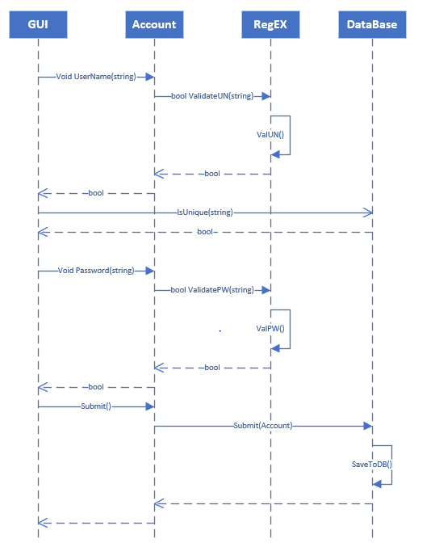

## Logging In

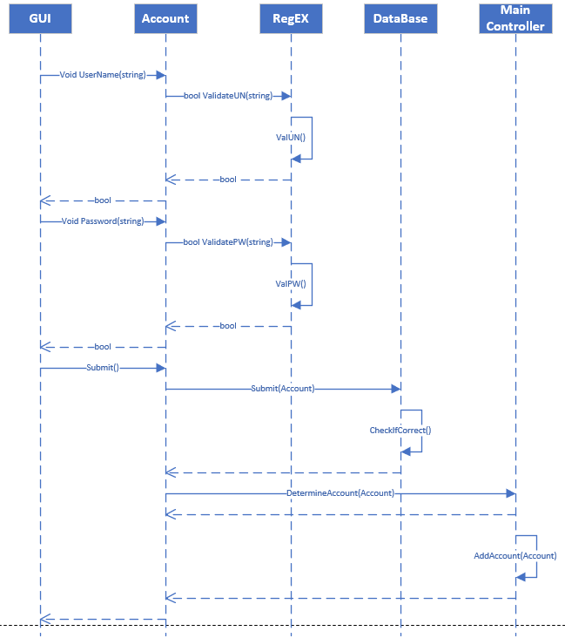

## Add Chore

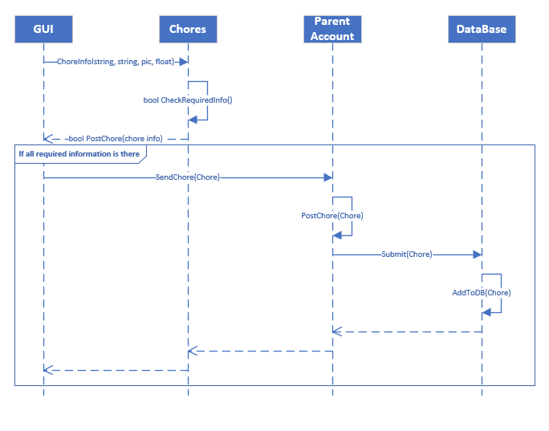

## Adding Child Account

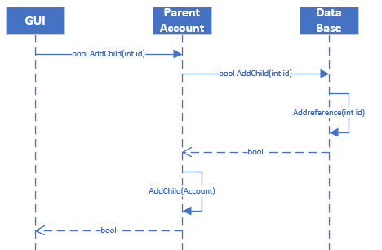

## Paying out child

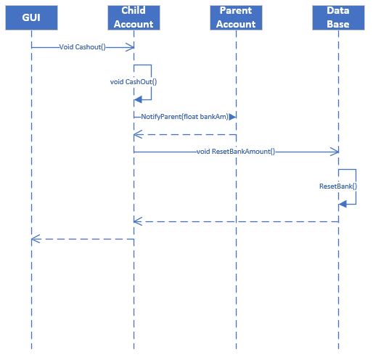

## Child Completing a Chore

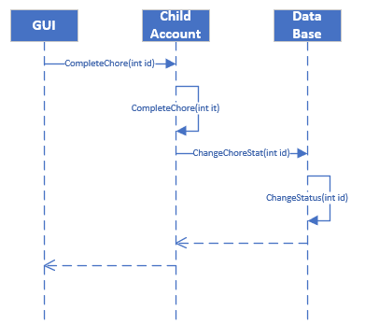

## Approving a chore

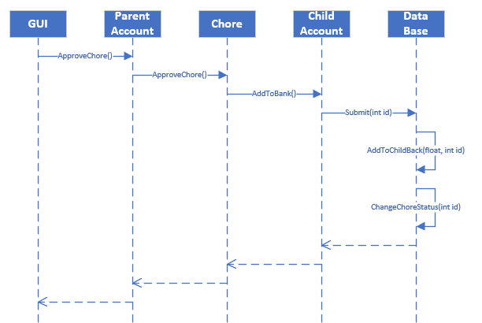

## Switch Account

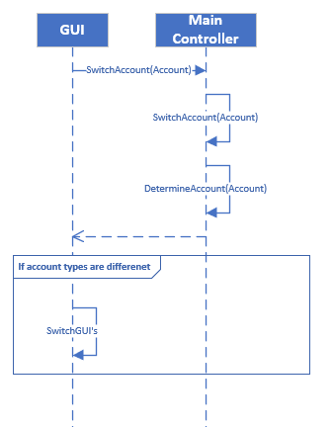

## Account Page

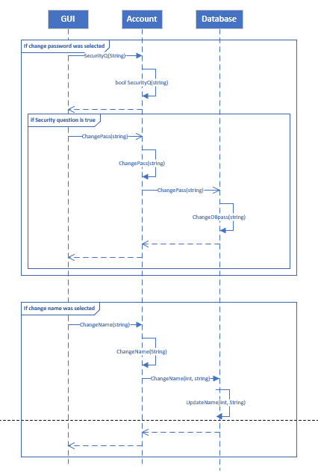

# Glossary

**Bank-** A child accounts accrued money through doing chores.

**Payout-** Resetting a child’s bank back to 0 after selecting this option. Parent’s account gets notified of them wanting to get paid out.

**DB-** Abbreviation for database.

**Child-** Abbreviation for child account.

**Parent-**Abbreviation for parent account.

# Appendix A

## Business Rules

-No business rules that I can think of at the moment.